Beginning of the Universe
Adjusted Assessment

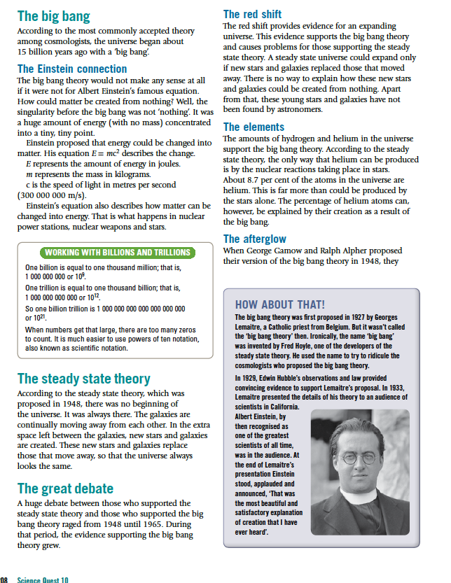

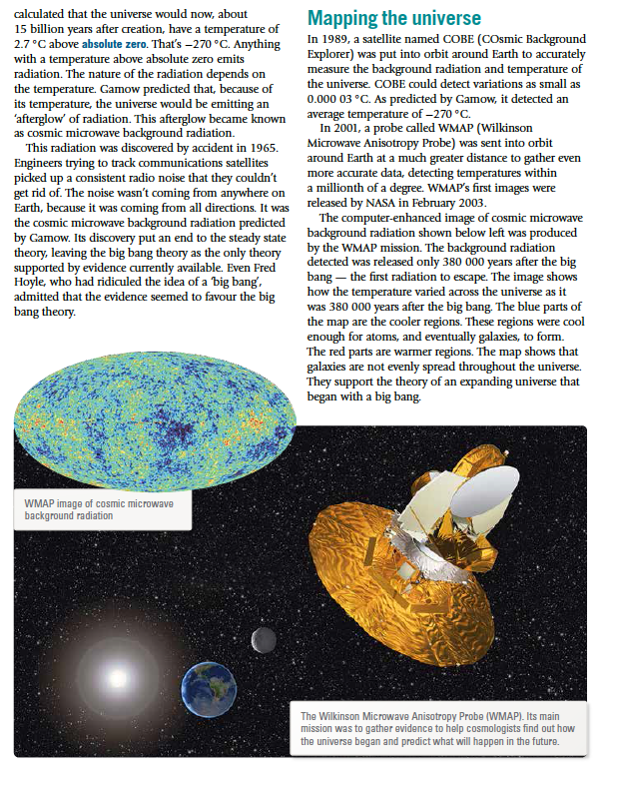

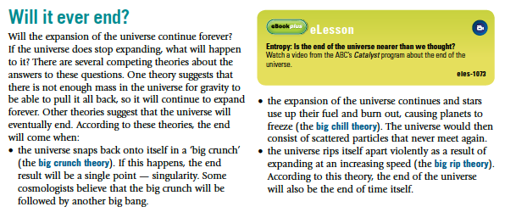

As you complete these questions, highlight the answers in the text above. Use Notability.

Questions

1. How old is the universe thought to be?

(1)

2. According to the Big Bang Theory, what was there at the time of the universe
starting?

(1)

3. What does Einstein's equation (E = mc²) have to do with the Big Bang Theory?

(1)

4. Who proposed the Big Bang Theory?

(1)

5. Which of the two theories about the "beginning" of the universe proposed that there
was no beginning?

(1)

6. How did the Steady State Theory explain that the universe was expanding, yet
the universe looked the same?

(1)

7. What piece of evidence discovered in 1965 put an end to the Steady State theory?

(1)

8. Give one piece of evidence that supported the Big Bang Theory.

(1)

9. Name and describe three theories about how the universe might end.

•

•

•

(3)

